**STUDENT MANAGEMENT SYSTEM**

**A PROJECT REPORT**

**For**

**Mini Project (KCA353)**

**Session (2023-24)**

**Submitted by**

**Sheetal Gupta**

**(2200290140142)**

**Submitted in partial fulfilment of the**

**Requirements for the Degree of**

**MASTER OF COMPUTER APPLICATION**

**Under the Supervision of**

**Dr. Shashank Bhardwaj**

### Associate Professor



**Submitted to**

**Department Of Computer Applications**

**KIET Group of Institutions, Ghaziabad**

**Uttar Pradesh-201206**

**(MARCH 2024)**

**DECLARATION**

I hereby declare that the work presented in report entitled “Student Management System” was carried out by me. I have not submitted the matter embodied in this report for the award of any other degree or diploma of any other University of Institute. I have given due credit to the original authors/sources for all the words, ideas, diagrams, graphics, computer programs, that are not my original contribution. I have used quotation marks to identify verbatim sentences and give credit to the original authors/sources. I affirm that no portion of my work is plagiarized, and the experiments and results reported in the report are not manipulated. In the event of a complaint of plagiarism and the manipulation of the experiments and results, I shall be fully responsible and answerable.

**Name:** Sheetal Gupta

**Roll No.:** 2200290140142

**(Candidate Signature)**

**CERTIFICATE**

Certified that **Sheetal Gupta 2200290140142** has carried out the project work having “**Student Management System**” (**Mini Project-KCA353**) for **Master of Computer Application** from Dr. A.P.J. Abdul Kalam Technical University (AKTU**)** (formerly UPTU), Lucknow under my supervision. The project report embodies original work, and studies are carried out by the student herself and the contents of the project report do not form the basis for the award of any other degree to the candidate or to anybody else from this or any other University/Institution.

**Date: Sheetal Gupta (2200290140142)**

This is to certify that the above statement made by the candidate is correct to the best of my knowledge.

Date:

**Dr. Shashank Bhardwaj Dr. Arun Tripathi**

**Associate Professor Head**

**Department of Computer Applications Department of Computer Applications**

**KIET Group of Institutions, Ghaziabad KIET Group of Institutions, Ghaziabad**

**ABSTRACT**

The Student Management System is a comprehensive project aimed at developing a robust and scalable platform, closely resembling the popular accountability service. This project has been undertaken with the goal of providing users with a familiar and feature-rich experience, encompassing the entire software development lifecycle from conceptualization to deployment.

The project incorporates key functionalities of a Student Result Management System, which includes user registration, profile creation, student add/remove functionality, and result generation. Leveraging modern web technologies and frameworks, the system boasts a user-friendly interface, ensuring ease of navigation and interaction for all users.

Furthermore, a secure authentication system has been implemented to safeguard sensitive user data and ensure that only authorized individuals have access to specific features and information within the system.

Efficient data storage is achieved through the utilization of a relational database, ensuring that student records and results are stored in a structured and organized manner, facilitating easy retrieval and manipulation as needed.

Overall, the Student Management System aims to streamline administrative processes related to student management while providing administrators, educators, and students with a reliable and intuitive platform for accessing and managing academic information effectively.

**ACKNOWLEDGEMENTS**

Success in life is never attained single-handedly. My deepest gratitude goes to my project supervisor, **Dr. Shashank Bhardwaj** for his guidance, help, and encouragement throughout my project work. Their enlightening ideas, comments, and suggestions.

Words are not enough to express my gratitude to **Dr. Arun Kumar Tripathi**, Professor and Head, Department of Computer Applications, for his insightful comments and administrative help on various occasions.

Fortunately, I have many understanding friends, who have helped me a lot on many critical conditions.

Finally, my sincere thanks go to my family members and all those who have directly and indirectly provided me with moral support and other kind of help. Without their support, completion of this work would not have been possible in time. They keep my life filled with enjoyment and happiness.

**TABLE OF CONTENTS**

Name of ContentPage no.

1. Declaration………………………………………………………………………..2

B). Certificate…………………………………………………………………..........3

C). Abstract………………………………………………………………………….4

D). Acknowledgement………………………………………………………………5

E). Table of Content…………………………………………………………………6 - 7

F). List of Abbreviation………………………………………………………………8

G). List of Table………………………………………………………………………9

1. Introduction**………………………………………………………………….……….**10-11

1.1 - Overview……………………………………………………………………/…..10

1.2 - Project Description…………………………………………………….…………10

1.2.1 Project Scope……………………………………………………..………….10

1.2.2 Target Audience………………………………………………….…………..10

1.3 - Hardware / Software……………………………………………………………..10

1.3.1 Hardware Requirement……………………………………………………….10

1.3.2 Software Requirement…………………………………………………………11

2. Feasibility Study**…………………………………………………………….…..........**12-13

2.1 - Technical Feasibility………………………………………………………….…...12

2.2 - Operational Feasibility……………………………………………………………..13

2.3 - Behavioural Feasibility………………………………………………………….13

3. Design**…………………………………………………………………….…………**14-22

3.1 Use Case Diagram…………………………………………………....……….14-15

3.1 Database Design……………………………………………………………….16-22

3.1.1 Admin Table………………………………………………………..........16

3.1.2 Class Table……………………………………………………...............17

3.1.3 Result Table……………………………………………………………..17

3.1.4 Student Table…………………………………………………………….18

3.1.5 Subject Table……………………………………………………………..18

3.2 - Flow Chart Diagrams……………………………………………….……….19-20

3.3 - Data Flow Diagrams………………………………………………………….20-22

4. Project Screenshots**……………………………………………………….……….**23-24

4.1 - Login Page……………………………………………………………… …….. 23

4.2 - Result Page……………………………………………………………………… 23

4.3 - Dashboard………………………………………………………………………..24

4.4 - Subject Page…………………………………………………………………….24

5. Testing**……………………………………………………………………………..**25-27

5.1 Testing Case……………………………………………………………………..25

5.2 Test Case………………………………………………………………………..26

5.2.1 Login Case ………………………………………………………………..27

5.2.2 Sign up Case……………………………………………………………….27

6. Future Scope**……………………………………………………………………..**29-30

6.1 Conclusion………………………………………………………………………29

7. Bibliography…………………………………………………………………………30

**LIST OF ABBREVIATIONS**

**Sr.no Abbreviation Definition**

1 HTML Hyper Text Mark-up Language

2 CSS Cascading Style Sheets

3 PHP Hypertext Pre - Pprocessor

4 DFD Data Flow Diagram

5 XAMPP Cross Platform Apache My SQL PHP Perl

6 MYSQL My Structured Query Language

**LIST OF TABLES**

**Sr.no Name of Table Page Number**

1 ADMIN 16

2 RESULT 17

3 STUDENT 18

4 RECORD 18

5 SUBJECT 18

**CHAPTER 1**

**INTRODUCTION**

* 1. **OVERVIEW**

The Student Result Management System, is a comprehensive endeavour to replicate the functionality and user experience of the renowned microblogging platform. Motivated by the desire to understand and implement key features of a modern Result Management System, this project encompasses a range of technical aspects spanning front-end development, back-end infrastructure, and real-time communication.

* 1. **PROJECT DESCRIPTION**

In today's fast-paced world, instant Result and Generating of ideas are paramount. Student Result Management System platforms have become a dominant force in this landscape, offering a familiar yet innovative experience for Developers.

**1.2.1 Project Scope:**

This will encompass the core functionalities of Result Management System, including:

**User registration and profiles:** Create accounts, edit profiles, and manage users.

**Interactions:** add, remove, and update the records.

* + 1. **Target Audience:**

This Platform targets individuals and communities seeking a dynamic platform for:

* **Sharing quick updates.**
* **Connecting with the Collaborators.**
* **Engaging in quality-based Record System.**
  1. **HARDWARE REQUIREMENTS**
* Hardware: Processor i3 or above
* Clock speed**:** 3.0 GHz
* RAM size**:** 4 GB or above
* Hard Disk capacity**:** 500 GB or above

* 1. **SOFTWARE REQUIREMENTS**
* Operating System**:** Windows 10
* Browser**:** Google chrome or any other
* Application software**:** Visual Studio Code
* Technology**:** PHP
* Server Required**:** XAMPP
* Language Required**:** HTML, CSS, JAVASCRIPT
* Documentation**:** MS Word

**CHAPTER 2**

**FEASIBILITY STUDY**

A feasibility study analyses the viability of a project to determine whether the project or venture is likely to succeed. The study is also designed to identify potential issues and problems that could arise while pursuing the project.

A feasibility study evaluates a project's or system's practicality. As part of a feasibility study, the objective and rational analysis of a potential business or venture is conducted to determine its strengths and weaknesses, potential opportunities and threats, resources required to carry out, and ultimate success prospects. Two criteria should be considered when judging feasibility: the required cost and expected value. A feasibility study is a comprehensive evaluation of a proposed project that evaluates all factors critical to its success in order to assess its likelihood of success. Business success can be defined primarily in terms of ROI, which is the amount of profits that will be generated by the project.

**2.1 TECHNICAL FEASIBILITY:**

Technical feasibility study is concerned with specifying equipment and software that will successfully satisfy the user requirement; the technical needs of the system may vary considerably. The facility to produce outputs in a given time. A technical feasibility study reviews the technical resources available for your project. This study determines if you have the right equipment, enough equipment, and the right technical knowledge to complete your project objectives.

For example, if your project plan proposes creating 50,000 products per month, but you can only produce 30,000 products per month in your factories, this project isn’t technically feasible. This assessment focuses on the technical resources available.

To the organization. It helps organizations determine whether the technical resources meet capacity and whether the technical team is capable of converting the ideas into working systems. Technical feasibility also involves the evaluation of the hardware,

Software, and other technical requirements of the proposed system. As an exaggerated example, an organization wouldn’t want to try to put Star Trek’s transporters in their building—currently, this project is not technically feasible.

**2.2 BEHAVIOURAL FEASIBILITY**

Behavioural feasibility is a critical aspect to consider when developing a Twitter clone project. This feasibility study assesses whether users and stakeholders are likely to accept and adapt to the new microblogging platform based on their behavioural patterns, preferences, and expectations. The literature on behavioural feasibility for social media platforms, including microblogging services, can provide valuable insights into user behaviour and acceptance. Behavioural feasibility for a Twitter clone project involves a comprehensive analysis of user behaviour, preferences, and cultural considerations.

Drawing upon existing literature on user behaviour in social media, UX design, feature acceptance, community building, adoption patterns, and user feedback can provide a solid foundation for developing a microblogging platform that aligns with user expectations and encourages widespread adoption.

**2.3 OPERATIONAL FEASIBILTY**

Operation feasibility is used to check whether the project is operationally feasible or not. Our project is mainly different from the other system because of its web-support feature. So the measure for operational feasibility is something different from other system.

Generally, the operational feasibility is related to organization aspects. The change determination is as such that early product were either a man or group of men or the jobs

Based manual but now a day with the advent of Internet technology. This assessment involves undertaking a study to analyse and determine whether—and how well—the organization’s needs can be met by completing the project.

Operational feasibility studies also examine how a project plan satisfies the requirements identified in the requirements analysis phase of system development. This assessment typically involves a cost/ benefits analysis of the project, helping organizations determine the viability, cost, and benefits associated with a project before financial resources are allocated.

**CHAPTER 3**

**DESIGN**

Software design sits at the technical kernel of the software engineering process and is applied regardless of the development paradigm and area of application. Design is the first step in the development phase for any engineered product or system. The designer’s goal is to produce a model or representation of an entity that will later be built. Beginning, once system requirement have been specified and analysed, system design is the first of the three technical activities - design, code and test that is required to build and verify software. The importance can be stated with a single word “Quality”.

Design is the place where quality is fostered in software development. Design provides us with representations of software that can assess for quality. Design is the only way that we can accurately translate a customer’s view into a finished software product or system. Software design serves as a foundation for all the software engineering steps that follow. Without a strong design we risk building an unstable system – one that will be difficult to test, one whose quality cannot be assessed until the last stage.

During design, progressive refinement of data structure, program structure, and procedural details are developed reviewed and documented. System design can be viewed from either technical or project management perspective. From the technical point of view, design is comprised of four activities – architectural design, data structure design, interface design and procedural design. System Design is the process of designing the architecture, components, and interfaces for a system so that it meets the end-user requirements.

System Design for tech interviews is something that can’t be ignored! Almost every IT giant whether it be Facebook, Amazon, Google, Apple or any other ask various questions based on System Design concepts such as scalability, load-balancing, caching, etc. in the interview. This specifically designed System Design tutorial will help you to learn and master System Design concepts in the most efficient way from basics to advanced level.

**3.1 USE CASE DIAGRAM**

In the Unified Modelling Language (UML), a use case diagram can summarize the details of your system's users (also known as actors) and their interactions with the system. To build one, you'll use a set of specialized symbols and connectors. A use case diagram doesn't go into a lot of detail—for example, don't expect it to model the order in which steps are performed. Instead, a proper use case diagram depicts a high-level overview of the relationship between use cases, actors, and systems. Experts recommend that use case diagrams be used to supplement a more descriptive textual use case.

UML is the modelling toolkit that you can use to build your diagrams. Use cases are represented with a labelled oval shape. Stick figures represent actors in the process, and the actor's participation in the system is modelled with a line between the actor and use case. To depict the system boundary, draw a box around the use case itself.

These diagrams are used at a very high level of design. This high level design is refined again and again to get a complete and practical picture of the system. A well-structured use case also describes the pre-condition, post condition, and exceptions. These extra elements are used to make test cases when performing the testing.

Although use case is not a good candidate for forward and reverse engineering, still they are used in a slightly different way to make forward and reverse engineering. The same is true for reverse engineering. Use case diagram is used differently to make it suitable for reverse engineering.

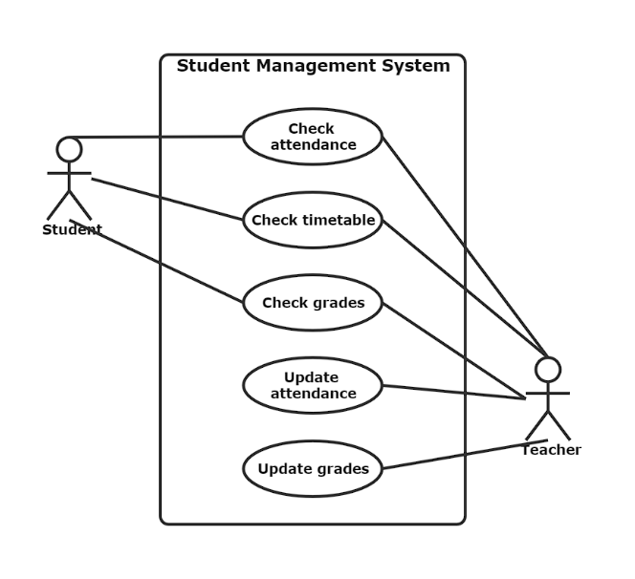

Figure 3.1: Use Case Diagram (3.1)

**3.1 DATABASE TABLES**

**3.1.1 ADMIN TABLE**

|  |  |  |
| --- | --- | --- |
| **FIELD** | **TYPE** | **CONSTRAINTS** |
| Username | Varchar2(255) | - |
| Password | Varchar2(255) | - |

Table No 3.1 Admin

**3.1.2 TABLE CLASSES**

|  |  |  |
| --- | --- | --- |
| **FIELD** | **TYPE** | **CONSTRAINTS** |
| Id | Int | PRIMARY KEY |
| CLASSNAME | VARCHAR | NOT NULL |
| SECTION | CHAR | NOT NULL |

Table no 3.2 Classes

**3.1.3 TABLE RESULT**

|  |  |  |
| --- | --- | --- |
| **FIELD** | **TYPE** | **CONSTRAINTS** |
| ID | NUMBR | PRIMARY KEY |
| STUDENT_ID | NUMBER | NOT NULL |
| CLASS_ID | NUMBER | NOT NULL |
| SUBJECT_ID | NUMBER | NOT NULL |
| MARKS | NUMBER | NOT NULL , DEFAULT |

Table no 3.3 Result

**3.1.4 STUDENT TABLE**

|  |  |  |
| --- | --- | --- |
| **FIELD** | **TYPE** | **CONSTRAINTS** |
| STUDENT_ID | Int(11) | NOT NULL |
| STUDENT_NAME | Varchar2(225) | DEFAULT NULL |
| EMAIL | VARCHAR2 | NOT NULL |
| ROLL NUMBER | NUMBER | - |
| GENDER | CHAR | - |
| DOB | DATE | - |

Table No 3.4 Student

**3.1.5 SUBJECT TABLE**

|  |  |  |
| --- | --- | --- |
| **FIELD** | **TYPE** | **CONSTRAINTS** |
| Id | Int(11) | NOT NULL |
| SUBJECT_NAME | Int(11) | NOT NULL |
| SUBJECT_CODE | Int(11) | NOT NULL |

Table No 3.5 Subject

**3.2 FLOWCHART DIAGRAM**

Flowcharts are nothing but the graphical representation of the data or the algorithm for a better understanding of the code visually. It displays step-by-step solutions to a problem, algorithm, or process. It is a pictorial way of representing steps that are preferred by most beginner-level programmers to understand algorithms of computer science, thus it contributes to troubleshooting the issues in the algorithm.

A flowchart is a picture of boxes that indicates the process flow in a sequential manner. Since a flowchart is a pictorial representation of a process or algorithm, it’s easy to interpret and understand the process.

To draw a flowchart, certain rules need to be followed which are followed by all professionals to draw a flowchart and is widely accepted all over the countries.

**3.2.1 Process flowchart:**

This type of flowchart shows all the activities that are involved in making a product. It basically provides a pathway to analyse the product to be built. A process flowchart is most used in process engineering to illustrate the relation between the major as well as minor components present in the product. It is used in business product modelling to help understand employees about the project requirements and gain some insight about the project.

**3.2.2** **Data flowchart:**

As the name suggests, the data flowchart is used to analyse the data, specifically it helps in analysing the structural details related to the project. Using this flowchart, one can easily understand the data inflow and outflow from the system. It is most commonly used to manage data or to analyse information to and fro from the system.

**3.2.3 Business Process Modelling Diagram:**

Using this flowchart or diagram, one can analytically represent the business process and help simplify the concepts needed to understand business activities and the flow of information. This flowchart illustrates the business process and models graphically which paves a way for process improvement.

**Flow Chart**

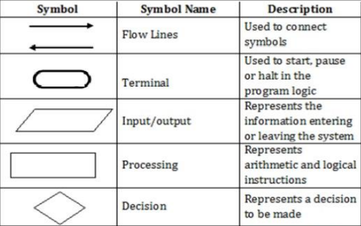

Figure: 3.2.1 Flow Chart

**3.3 DATA FLOW DIAGRAM**

**DFD** is the abbreviation for **Data Flow Diagram**. The flow of data of a system or a process is represented by DFD. It also gives insight into the inputs and outputs of each entity and the process itself. DFD does not have control flow and no loops or decision rules are present. Specific operations depending on the type of data can be explained by a flowchart. It is a graphical tool, useful for communicating with users, managers and other personnel. It is useful for analysing existing as well as proposed system.

It provides an overview of

* What data is system processes.
* What transformation are performed.
* What data are stored?
* What results are produced etc.?

Data Flow Diagram can be represented in several ways. The DFD belongs to structured- analysis Modelling tools. Data Flow diagrams are very popular because they help us to visualize the major steps and data involved in software-system processes.

The Data Flow Diagram has 4 components:

* Process Input to output transformation in a system takes place because of process function. The symbols of a process are rectangular with rounded corners, oval, rectangle or a circle. The process is named a short sentence, in one word or a phrase to express its essence
* Data Flow Data flow describes the information transferring between different parts of the systems. The arrow symbol is the symbol of data flow. A relatable name should be given to the flow to determine the information which is being moved. Data flow also represents material along with information that is being moved. Material shifts are modelled in systems that are not merely informative. A given

Flow should only transfer a single type of information. The direction of flow is represented by the arrow which can also be bi-directional.

* Warehouse The data is stored in the warehouse for later use. Two horizontal lines represent the symbol of the store. The warehouse is simply not restricted to being a data file rather it can be anything like a folder with documents, an optical disc, a filing cabinet. The data warehouse can be viewed independent of its implementation. When the data flow from the warehouse it is considered as data reading and when data flows to the warehouse it is called data entry or data updating.
* Terminator The Terminator is an external entity that stands outside of the system and communicates with the system. It can be, for example, organizations like banks, groups of people like customers or different departments of the same organization, which is not a part of the model system and is an external entity. Modelled systems also communicate with terminator.

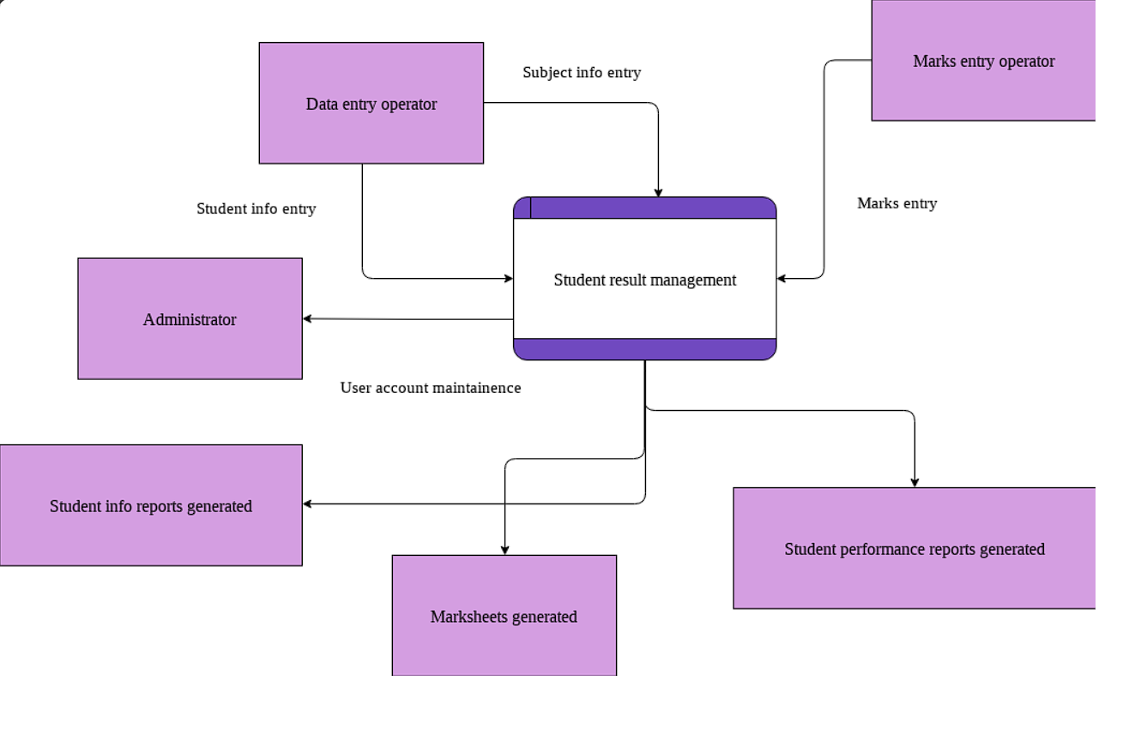Figure 3.1 Data Flow Diagram

**CHAPTER 4**

**PROJECT SCREENSHOTS**

**Login Page**

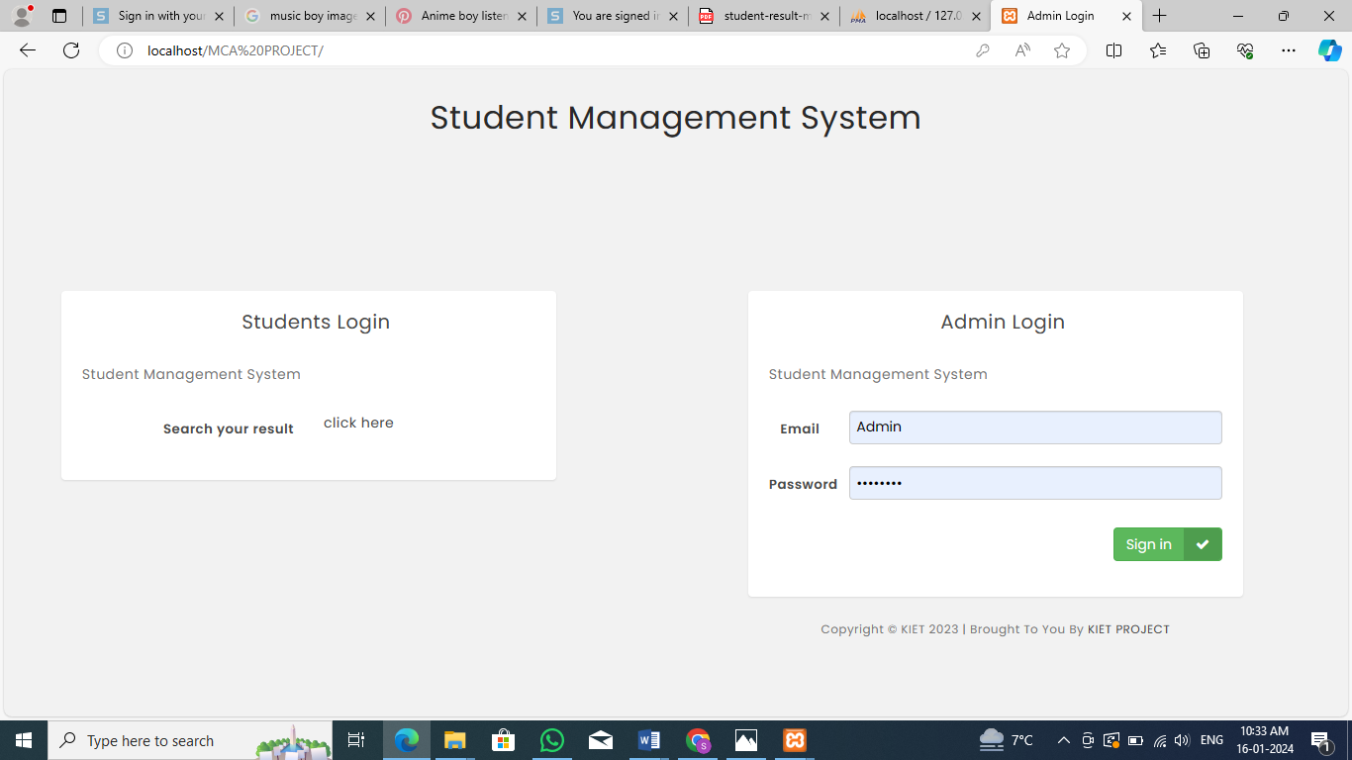

Figure 4.1 Login Page

**Result Page**

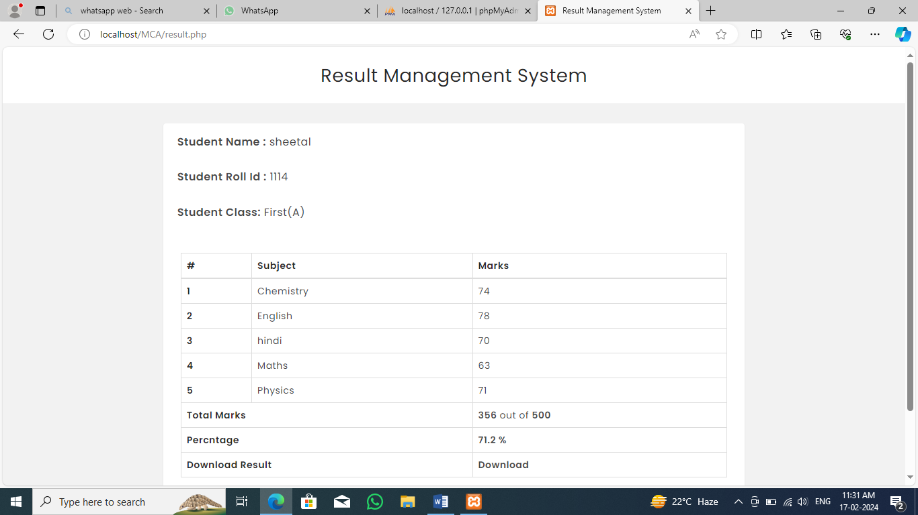

Figure 4.2: Result Page

**Dashboard**

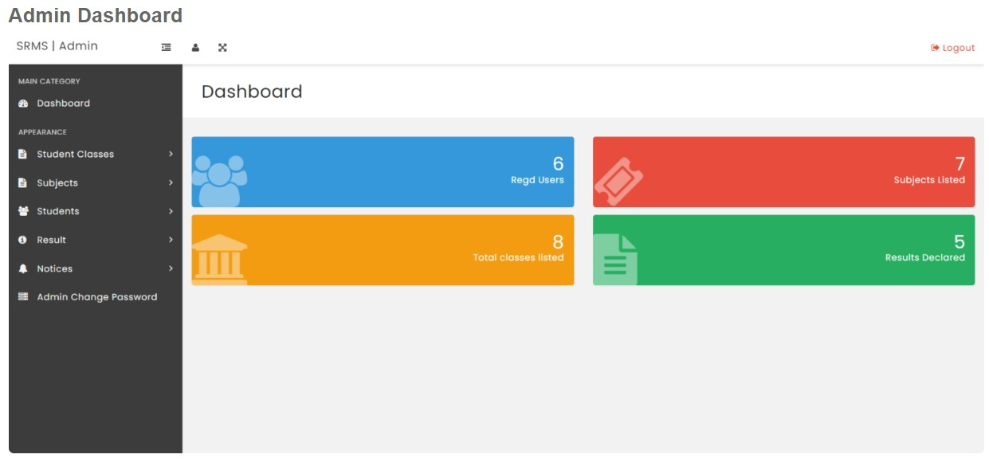

Figure 4.3: Dashboard

**Subject Page**

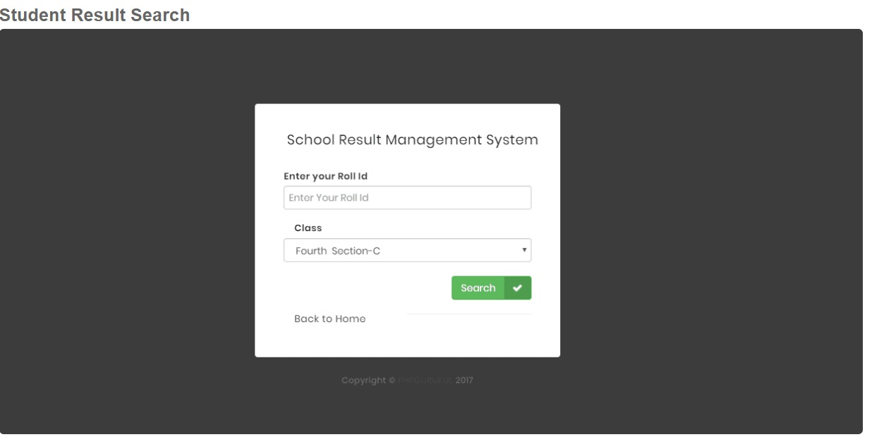

Figure 4.4: Subject Page

**CHAPTER 5**

**TESTING**

Testing is a process of executing a program with the intent of finding bugs that makes the application fail to meet the expected behaviour. System Analysis and Design process including Requirement Analysis, Business Solution Options, Feasibility Study, and Architectural Design was discussed in previous chapter. Generally Software bugs will almost always exist in any software module. But it is not because of the carelessness or irresponsibility of programmer but because of the complexity.

Humans have only limited ability to manage complexity. This chapter discusses about the testing of the solution and implementation methodologies. Regardless of the development methodology, the ultimate goal of testing is to make sure that what is created does what it is supposed to do. Testing plays a critical role for assuring quality and reliability of the software. I have included testing as a part of development process. The test cases should be designed with maximum possibilities of finding the errors or bugs. Software Testing is the process of executing a program or system with the intent of finding errors. The scope of software testing often includes examination of code as well as execution of that code in various environments and conditions.

Software Testing is a method to check whether the actual software product matches expected requirements and to ensure that software product is Defect free. It involves execution of software/system components using manual or automated tools to evaluate one or more properties of interest. The purpose of software testing is to identify errors, gaps or missing requirements in contrast to actual requirements. Testing stage of The project can be explained as below and system was tested for all these stages. Various level of testing are as follows

**5.1 TESTING LEVELS**

**Unit testing**: Unit testing tests the functionality of individual units of source code. It is the smallest component of a testable software that works in isolation with other parts of the code. I have done unit testing for various individual components of the source code to uncover errors within the boundary of the application.

**Integration testing:** Integration testing focuses on the design and construction of the software. Here the individual components that are tested using unit tests are combined and tested as a group. Its primary purpose is to expose the defects associated with the interfacing of modules. It checks if the modules perform the desired functionality when integrated together

**System testing:** System testing is performed on a completely integrated system to see if it meets the requirements, System Testing is a type of software testing that is performed on a complete integrated system to evaluate the compliance of the system with the corresponding requirements. In system testing, integration testing passed components are taken as input.

**Regression testing:** Regression testing aims at verifying the functionality of the software that is previously tested and to which changes are made. It is to ensure the old software still works with new changes.

**Acceptance testing**: Acceptance testing is conducted to verify if the system compliance the business requirements. Software Testing is a method to check whether the actual software product matches expected requirements and to ensure that software product is Defect free. It involves execution of software/system components using manual or automated tools to evaluate one or more properties of interest. The purpose of software testing is to identify errors, gaps or missing requirements in contrast to actual requirements.

Adhering to the levels of testing, Unit testing is performed on individual components of the system ensuring the expected behaviour. Later, I have integrated various components together and performed Integration testing. Once the integration testing is done, I have

Performed System 30 testing and ensured the application works as per the requirements. Finally, acceptance testing is performed to check if the client accepts the system

**Performance Testing:** Performance testing is performed to determine how well the system can perform in terms of responsiveness under all kinds of load. The web application is tested to see if it can sustain huge amount of requests providing higher throughput under different loads. I have simulated multiple hits on various pages of the application to evaluate the overall performance.

**5.2 TEST CASE**

**5.2.1 FOR USER SIGNUP**

|  |  |
| --- | --- |
| **FIELD** | **DETAILS** |
| Email | Example123@gmail.com |
| Username | Test |
| Password | ****** |

Table: Record entered successfully

**5.2.2 LOGIN CASE**

|  |  |
| --- | --- |
| **FIELD** | **DETAILS** |
| Email | Example123@gmail.com |
| Password | ****** |

Table: Logged in successfully

**CHAPTER 6**

**FUTURE SCOPE AND CONCLUSION**

The future of the Twitter clone holds immense potential for growth and innovation. Here are some key areas for future development:

* 1. **ENHANCED USER EXPERIENCE:**
* Implementing advanced algorithms for personalized content delivery based on user preferences and behaviour.
* Integration of augmented reality (AR) and virtual reality (VR) elements to create a more immersive user experience.
  1. **ADVANCED CONTENT MODERATION:**
* Leveraging machine learning and artificial intelligence for more effective and nuanced content moderation, reducing the prevalence of harmful or inappropriate content.
* Incorporating blockchain technology to ensure transparency and accountability in content moderation decisions.
  1. **MONETIZATION STRATEGIES:**
* Introduction of innovative monetization features, such as exclusive content subscriptions, premium user accounts, and a decentralized tipping system.
* Exploring partnerships with businesses for targeted advertising and sponsored content.
  1. **GLOBAL EXPANSION:**
* Focusing on expanding user bases in untapped markets and regions to create a truly global social media platform.
* Localization efforts to cater to diverse linguistic and cultural preferences.

**6.5 INTEROPERABILITY AND INTEGRATION:**

* Facilitating seamless integration with other popular social media platforms and communication tools.
* Exploring interoperability with emerging technologies, such as the integration of decentralized identity systems.

**CHAPTER 7**

**CONCLUSION**

In conclusion, a student management system is a valuable tool for educational institutions to efficiently manage various aspects of student information and academic processes. Through features such as student profiles, attendance tracking, grading systems, and communication tools, these systems streamline administrative tasks, improve communication between stakeholders, and provide valuable insights into student performance and progress. Some key benefits of student management systems include:

**7.1 ENHANCED ORGANIZATION**

* Centralizing student data and administrative tasks helps institutions stay organized and reduces the likelihood of errors or oversights.

**7.2 IMPROVED COMMUNICATION**

* Built-in communication tools allow for easier collaboration between students, teachers, administrators, and parents, facilitating timely updates and feedback.

**7.3 INCREASED EFFICIENCY**

* Automation of routine tasks such as attendance tracking, grading, and scheduling frees up time for educators to focus on teaching and student support.

**BIBLIOGRAPHY**

[1] Introduction To PHP Retrieved on 10/10/2023 from <https://www.tutorialspoint.com/php/index.html>

[2] <https://www.udemy.com/course/create-a-twitter-clone-with-php-mysql-and-js-from-scratch/>

[3] <https://www.geeksforgeeks.org/php-tutorial/>

[4] <https://www.javatpoint.com/php-tutorial>

[5] <https://www.javatpoint.com/javascript-tutorial>